SIMATS ENGINEERING
ASSESSMENT TOOL 3
NAME: SHIVA RANGA REDDY S
REG NO: 192411178
COURSE NAME: INTERNET PROGRAMMING
COURSE CODE: CSA43

COURSE OUTCOME COVERED

CO-2 : Apply CSS layout and styling techniques to create visually appealing and responsive web interfaces, and use JavaScript to enable interactive client-side behavior. (L3)

Assessment Tool : Short Answer Test

Weightage: 10%

QUESTIONS: Total Marks: 20

Question 1 (5 Marks)
Suppose that a company wants its website to work seamlessly on mobile, tablet, and desktop devices. Explain the concept of responsive web design and its importance. Describe the key CSS techniques used to achieve responsiveness, and explain how CSS Flexbox or Grid can be used to design adaptive layouts. Illustrate your answer with a simple example layout and suggest improvements to enhance user experience across different devices.
ANS:
Responsive web design and adaptive layouts
A company wants its website to work seamlessly on mobile, tablet, and desktop devices. This can be achieved using responsive web design (RWD).
Responsive web design (RWD)
Responsive web design is a web development approach in which a website automatically adjusts its layout, images, text, and navigation according to the screen size and resolution of the user’s device. A responsive website provides a consistent and user-friendly experience across all devices without creating separate websites.
Importance of responsive web design
Responsive web design is important because it:
- Improves user experience.
- Supports mobile, tablet, and desktop users.
- Reduces horizontal scrolling and zooming.
- Increases website accessibility.
- Improves SEO (search engine optimization).
- Reduces development and maintenance costs.
- Increases customer satisfaction and engagement.
Key CSS techniques for responsiveness
Fluid layouts
Use flexible units such as percentages instead of fixed pixel values.
.container{
width:90%;
margin:auto;
}
Flexible images
Images automatically resize according to the screen size.
img{
max-width:100%;
height:auto;
}
Media queries
Media queries apply different styles for different screen sizes.
@media (max-width:768px){
.container{
width:100%;
}
}
Relative units
Use %, em, rem, vw, and vh for scalable layouts and typography.
Using CSS Flexbox for adaptive layouts
Flexbox makes it easy to create flexible layouts that automatically adjust based on available space.
HTML
<div class="container">
<div class="box">Sidebar</div>
<div class="box">Content</div>
<div class="box">Extra</div>
</div>
CSS
.container{
display:flex;
gap:20px;
}

.box{
flex:1;
padding:20px;
background:lightblue;
}

@media (max-width:768px){
.container{
flex-direction:column;
}
}
In desktop view, the three sections appear side by side. On tablets and mobile devices, the sections stack vertically.
Example responsive website
HTML
<!DOCTYPE html>
<html>
<head>
<link rel="stylesheet" href="style.css">
</head>
<body>

<header>
<h1>Responsive Website</h1>
</header>

<div class="container">
<aside class="sidebar">
Sidebar
</aside>

<main class="content">
<h2>Main Content</h2>
<img src="https://picsum.photos/800/300" alt="Image">
<p>This layout adjusts automatically for different devices.</p>
</main>
</div>

<footer>
Footer
</footer>

</body>
</html>
CSS
body{
font-family:Arial;
margin:0;
}

header,
footer{
background:#1976d2;
color:white;
text-align:center;
padding:20px;
}

.container{
display:flex;
gap:20px;
padding:20px;
}

.sidebar{
flex:1;
background:#e3f2fd;
padding:20px;
}

.content{
flex:3;
}

img{
max-width:100%;
height:auto;
}

@media (max-width:768px){
.container{
flex-direction:column;
}
}
Adaptive layout behavior
Desktop
Sidebar and content side by side
Sidebar
Main content
Tablet
Stacked with comfortable spacing
Sidebar
Main content
Mobile
Single-column mobile layout
Sidebar
Main content
Using CSS Grid
CSS Grid is another powerful layout system for responsive design.
.container{
display:grid;
grid-template-columns:1fr 3fr;
gap:20px;
}

@media (max-width:768px){
.container{
grid-template-columns:1fr;
}
}
Grid is useful for dashboards, galleries, and complex page layouts.
Improvements to enhance user experience
To provide a better experience across devices, the company should:
- Follow a mobile-first approach.
- Use responsive navigation menus.
- Increase button sizes for touch screens.
- Optimize images and media for faster loading.
- Use readable fonts and sufficient spacing.
- Maintain good color contrast for accessibility.
- Avoid fixed-width elements.
- Test on multiple screen sizes and browsers.
OUTPUT:
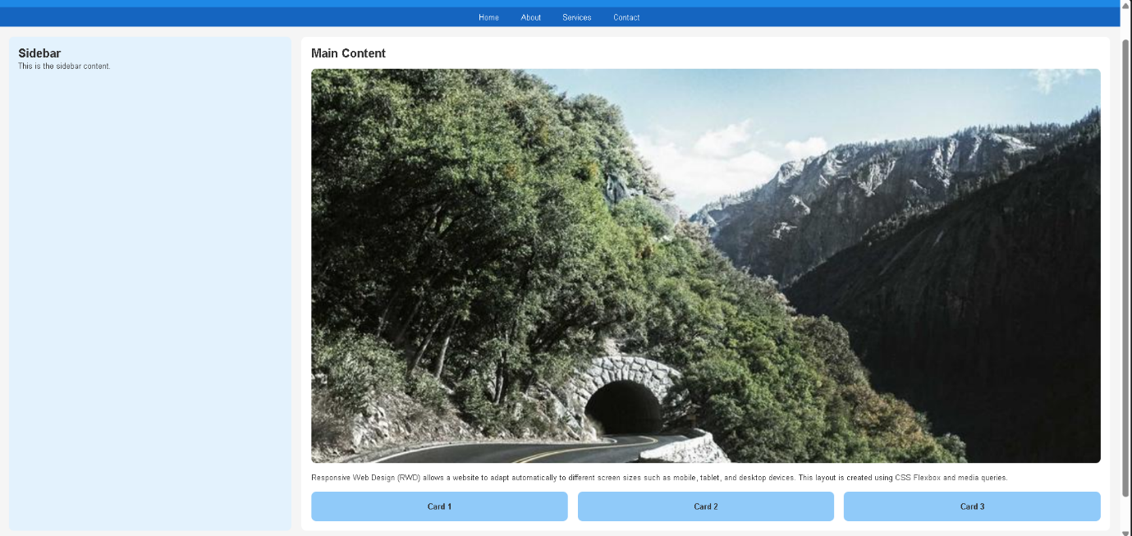
Conclusion
Responsive web design ensures that a website works efficiently on mobile, tablet, and desktop devices. By using fluid layouts, flexible images, media queries, and CSS Flexbox or Grid, developers can create adaptive layouts that improve usability, accessibility, SEO, and overall user satisfaction.

Question 2 (5 Marks)
Suppose that a webpage contains a form where user input must be validated before submission. Explain the concept of client-side validation and its purpose. Describe how JavaScript event handling is used in validation and explain the role of regular expressions in validating inputs such as email or phone numbers. Provide a suitable example and suggest improvements for better usability and security.
ANS:
Client-side validation and JavaScript form validation
When a webpage contains a form, the entered data should be checked before it is submitted to the server. This process is called client-side validation.
Client-side validation
Client-side validation is the process of verifying user input in the web browser using JavaScript before the form is submitted to the server. It helps ensure that the entered data is correct and complete.
Purpose of client-side validation
Client-side validation is used to:
- Prevent empty fields.
- Check correct input format.
- Reduce invalid data submission.
- Improve user experience.
- Reduce unnecessary server requests.
- Provide immediate feedback to users.
For example, it can verify that an email contains @, a phone number contains only digits, and required fields are not left blank.
JavaScript event handling in validation
JavaScript uses events to trigger validation when users interact with form elements.
Common events include:
Event | Purpose
submit | Validate before form submission
input | Validate while typing
change | Validate after field value changes
blur | Validate when a field loses focus
The submit event is commonly used to stop the form if validation fails.
Example:
form.addEventListener("submit", function(event){
if(!validateForm()){
event.preventDefault();
}
});
Here, event.preventDefault() prevents the form from being submitted.
Role of regular expressions (Regex)
A regular expression (regex) is a pattern used to match and validate text.
Regex is useful for checking:
- Email addresses.
- Phone numbers.
- Password strength.
- ZIP codes.
- Usernames.
Email regex
/^[^\\s@]+@[^\\s@]+\\.[^\\s@]+$/
This checks that the email has text before and after @ and contains a domain.
Phone number regex
/^[0-9]{10}$/
This accepts exactly 10 digits.
Example: form validation
HTML
<!DOCTYPE html>
<html>
<head>
<title>Form Validation</title>
</head>
<body>

<form id="myForm">
<label>Name:</label>
<input type="text" id="name"><br><br>

<label>Email:</label>
<input type="text" id="email"><br><br>

<label>Phone:</label>
<input type="text" id="phone"><br><br>

<button type="submit">Submit</button>
</form>

<p id="message"></p>

<script src="script.js"></script>

</body>
</html>
JavaScript
document.getElementById("myForm").addEventListener("submit", function(event){

let name = document.getElementById("name").value.trim();
let email = document.getElementById("email").value.trim();
let phone = document.getElementById("phone").value.trim();

let emailPattern = /^[^\\s@]+@[^\\s@]+\\.[^\\s@]+$/;
let phonePattern = /^[0-9]{10}$/;

let message = "";

if(name === ""){
message += "Name is required.\\n";
}

if(!emailPattern.test(email)){
message += "Invalid email address.\\n";
}

if(!phonePattern.test(phone)){
message += "Phone number must contain 10 digits.\\n";
}

if(message !== ""){
event.preventDefault();
document.getElementById("message").innerText = message;
}
});
How the validation works
- The user clicks Submit.
- The submit event is triggered.
- JavaScript reads the form values.
- Regex checks email and phone number formats.
- If any field is invalid, submission is prevented.
- Error messages are displayed.
Improvements for better usability
To improve user experience:
- Validate fields while typing using the input event.
- Display error messages next to each field.
- Highlight invalid fields with red borders.
- Show success indicators for valid inputs.
- Use placeholder text and helpful instructions.
- Preserve entered data when errors occur.
- Use appropriate input types such as email, tel, and number.
- Disable the submit button until required fields are valid.
Example:
emailInput.addEventListener("input", validateEmail);
This provides real-time validation.
Security improvements
Client-side validation improves usability but does not provide security because users can disable JavaScript or modify requests.
Therefore, the server must also perform server-side validation.
Important security measures include:
- Validate all inputs on the server.
- Sanitize user input.
- Use prepared statements to prevent SQL injection.
- Escape output to prevent XSS attacks.
- Enforce password policies.
- Use HTTPS.
- Limit request rates to prevent abuse.
Output:
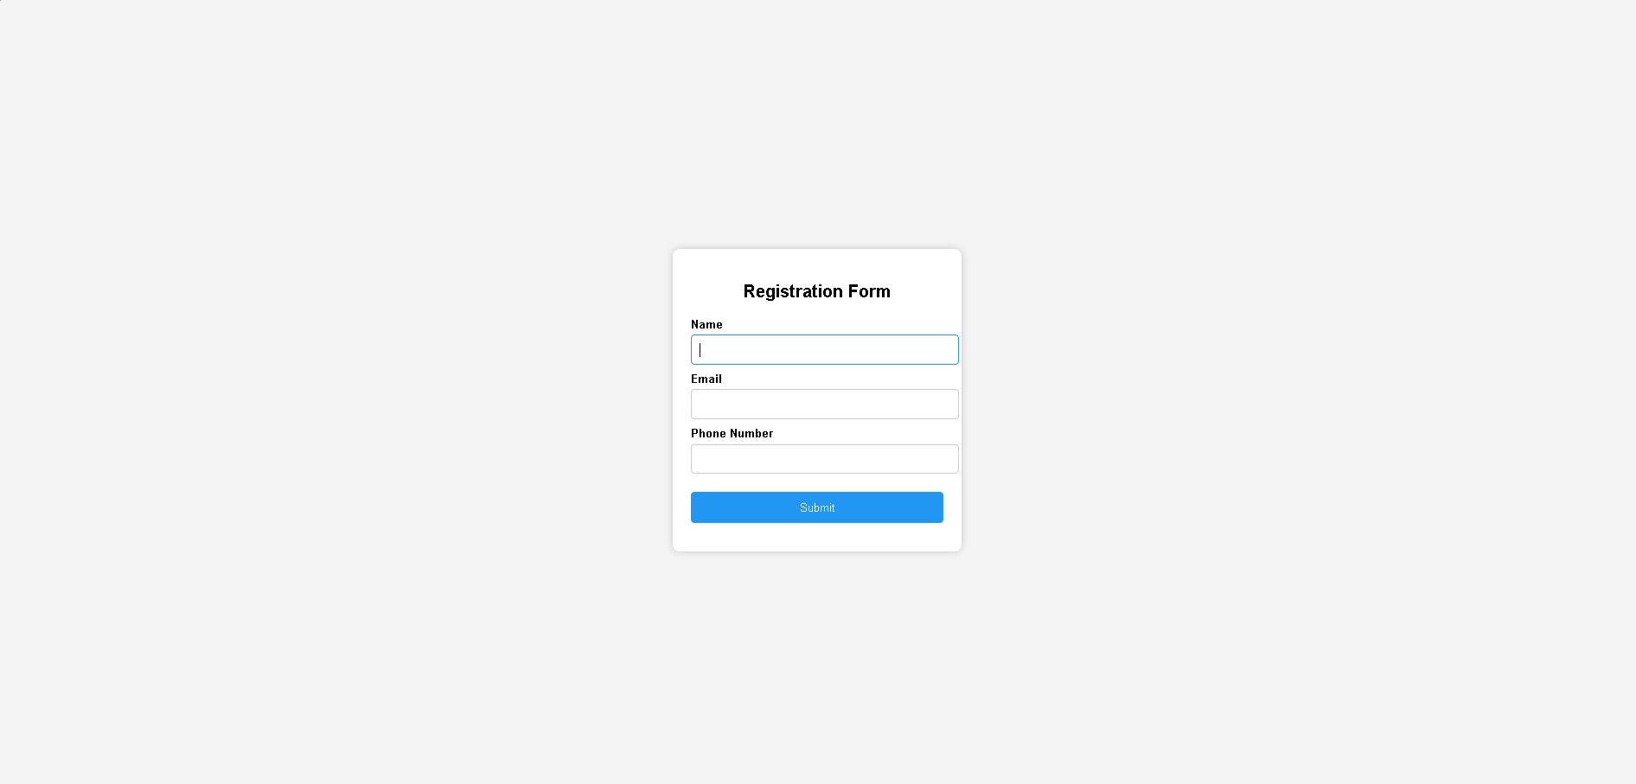
Conclusion
Client-side validation checks user input in the browser before submission, improving usability and reducing unnecessary server requests. JavaScript event handling enables validation during user interaction, while regular expressions verify formats such as email and phone numbers. Combining client-side validation with server-side validation and proper security measures provides both a better user experience and secure data processing.

Question 3 (5 Marks)
Suppose that a webpage layout breaks when the browser window is resized. Explain the CSS box model and its components, and describe how CSS positioning techniques affect layout structure. Identify possible causes of layout breaking and explain how media queries can be used to resolve these issues. Suggest best practices to ensure a stable and responsive layout.
ANS:
CSS box model, positioning, and responsive layout
When a webpage layout breaks after resizing the browser window, the problem is usually caused by fixed dimensions, incorrect positioning, or lack of responsive design. CSS provides the box model, positioning techniques, and media queries to create stable and responsive layouts.
CSS box model
The CSS box model describes how every HTML element is displayed as a rectangular box.
Margin
Border
Padding
Content
The box model consists of four components:
- Content – the actual text or image.
- Padding – space between the content and the border.
- Border – surrounds the padding and content.
- Margin – space outside the border that separates elements.
Example
.box{
width:300px;
padding:20px;
border:5px solid black;
margin:10px;
}
The total width becomes:
300 + 20 + 20 + 5 + 5 = 350px (excluding margins).
To avoid unexpected size calculations, use:
*{
box-sizing:border-box;
}
This includes padding and border within the specified width.
CSS positioning techniques
Positioning controls how elements are placed in the layout.
Position | Description
static | Default position
relative | Moves relative to its normal position
absolute | Removed from normal document flow
fixed | Fixed relative to the browser window
sticky | Acts relative until a scroll threshold, then sticks
Relative positioning
.box{
position:relative;
left:20px;
}
Absolute positioning
.box{
position:absolute;
top:50px;
left:100px;
}
Absolute positioning can cause overlapping and layout breaking because the element is removed from the normal document flow.
How positioning affects layout structure
Improper positioning can break layouts when the screen size changes.
For example:
- Absolute positioning may overlap content.
- Fixed-width sidebars may overflow on mobile devices.
- Fixed positioning may cover other elements.
- Negative margins may create unexpected alignment issues.
Possible causes of layout breaking
A layout may break due to:
- Fixed widths such as width:1200px.
- Large images without responsive sizing.
- Excessive margins or padding.
- Absolute positioning.
- Elements that do not wrap.
- Tables wider than the screen.
- Missing viewport meta tag.
- Lack of media queries.
Example of a problematic layout:
.container{
width:1200px;
}
On a mobile screen, horizontal scrolling occurs.
Using media queries to fix layouts
Media queries apply different CSS rules based on screen size.
Basic syntax
@media (max-width:768px){
.container{
width:100%;
}
}
Responsive layout example
HTML
<div class="container">
<div class="sidebar">Sidebar</div>
<div class="content">Main Content</div>
</div>
CSS
.container{
display:flex;
}

.sidebar{
width:300px;
}

.content{
flex:1;
}

@media (max-width:768px){
.container{
flex-direction:column;
}

.sidebar{
width:100%;
}
}
Layout behavior
Desktop
Sidebar and content side by side
Sidebar
Main content
Tablet and mobile
Columns stack vertically
Sidebar
Main content
The layout changes from two columns on desktop to one column on smaller screens, preventing overflow and overlap.
Best practices for a stable and responsive layout
To ensure a responsive layout:
- Use box-sizing:border-box.
- Prefer Flexbox or CSS Grid instead of floats.
- Use relative units such as %, rem, em, vw, and vh.
- Make images responsive using:
img{
max-width:100%;
height:auto;
}
- Avoid fixed widths.
- Minimize absolute positioning.
- Use media queries for breakpoints.
- Add the viewport meta tag:
<meta name="viewport" content="width=device-width, initial-scale=1.0">
- Test layouts on mobile, tablet, and desktop.
- Keep spacing and typography scalable.
- Allow content to wrap naturally.
Output:
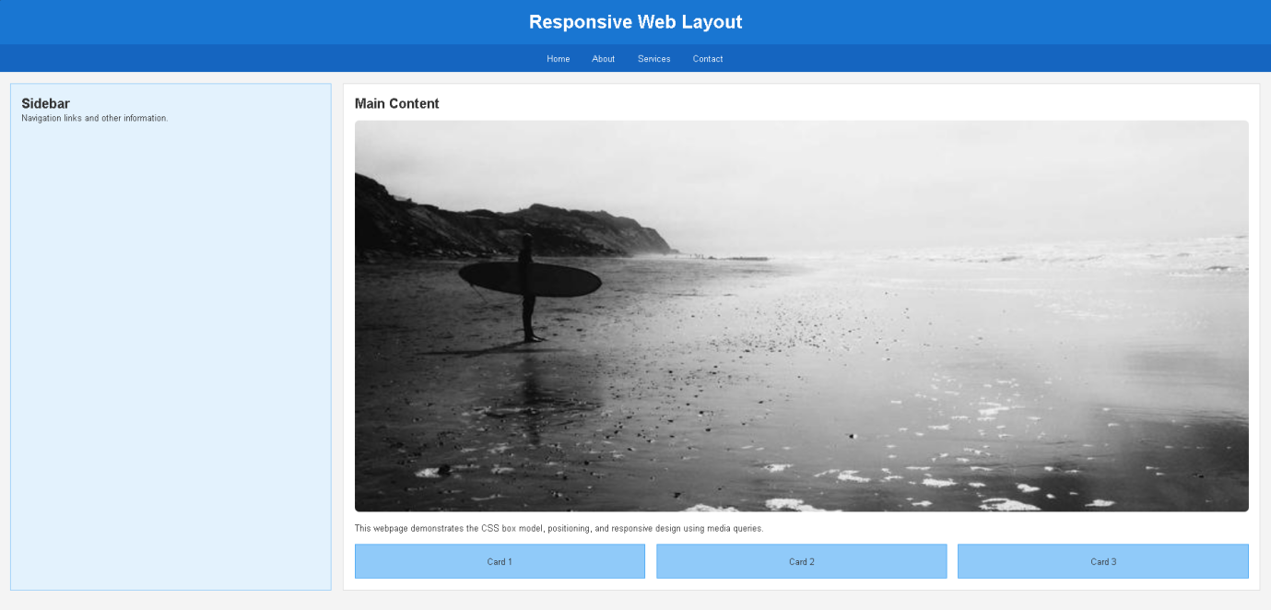
Conclusion
The CSS box model controls element dimensions through content, padding, border, and margin, while CSS positioning determines how elements are placed in the layout. Layout breaking often occurs because of fixed dimensions, incorrect positioning, or non-responsive elements. Media queries, combined with Flexbox/Grid and flexible sizing, create layouts that adapt smoothly to different screen sizes. Following responsive design best practices ensures a stable, flexible, and user-friendly webpage across all devices.

Question 4 (5 Marks)
Suppose that a website requires dynamic content updates without reloading the entire page. Explain the concept of the Document Object Model (DOM) and its role in web development. Describe how JavaScript can be used to manipulate the DOM for updating webpage content dynamically. Provide an example and suggest improvements to enhance performance and user experience.
ANS:

Document Object Model (DOM) and dynamic content updates

When a website needs to update content without reloading the entire page, JavaScript uses the Document Object Model (DOM) to modify webpage elements dynamically.

Document Object Model (DOM)

The Document Object Model (DOM) is a programming interface for HTML and XML documents. It represents a webpage as a tree structure of objects, where every HTML element becomes a node that JavaScript can access and modify.

For example, the HTML:

<body>

<h1>Welcome</h1>

<p>Hello User</p>

</body>

is represented as:

Document

html

body

h1

“Welcome”

p

“Hello User”

JavaScript can access any node and change its content, style, or structure.

Role of the DOM in web development

The DOM enables JavaScript to:

Access HTML elements.

Change text content.

Modify CSS styles.

Add or remove elements.

Handle user events.

Update page content dynamically.

Create interactive web applications.

Without the DOM, webpages would remain static after loading.

JavaScript DOM manipulation

JavaScript selects elements and modifies them using DOM methods.

Selecting elements

document.getElementById("title");

document.querySelector(".box");

document.querySelectorAll("p");

Updating content

element.innerHTML = "New Content";

element.textContent = "Updated Text";

Changing styles

element.style.color = "blue";

element.style.backgroundColor = "yellow";

Creating new elements

let p = document.createElement("p");

p.textContent = "New Paragraph";

document.body.appendChild(p);

Example: dynamic content update

HTML

<!DOCTYPE html>

<html>

<head>

<title>DOM Example</title>

</head>

<body>

<h1 id="title">Welcome</h1>

<p id="message">Click the button to update this text.</p>

<button onclick="updateContent()">

Update Content

</button>

<script src="script.js"></script>

</body>

</html>

JavaScript

function updateContent(){

document.getElementById("title").textContent =

"DOM Updated Successfully";

document.getElementById("message").innerHTML =

"The webpage content was updated dynamically without reloading.";

}

Output behavior

Initially:

Title: Welcome

Message: Click the button to update this text.

After clicking the button:

Title changes to DOM Updated Successfully

Message changes dynamically

The page does not reload

This demonstrates real-time DOM manipulation.

Dynamic updates using event handling

A better approach is using event listeners.

document.getElementById("btn")

.addEventListener("click", updateContent);

This separates JavaScript from HTML and improves maintainability.

Example: adding items dynamically

HTML

<ul id="list"></ul>

<button id="addBtn">Add Item</button>

JavaScript

document.getElementById("addBtn")

.addEventListener("click", function(){

let li = document.createElement("li");

li.textContent = "New Item";

document.getElementById("list")

.appendChild(li);

});

Each button click adds a new list item without refreshing the page.

Performance improvements

Frequent DOM manipulation can be slow because each change may trigger reflow and repaint.

To improve performance:

Cache DOM references.

Minimize repeated DOM access.

Update multiple elements together.

Use DocumentFragment for bulk updates.

Avoid excessive innerHTML usage.

Use event delegation for many elements.

Reduce unnecessary animations.

Example of caching:

let message = document.getElementById("message");

message.textContent = "Updated";

This avoids repeated DOM searches.

User experience improvements

To enhance usability:

Show loading indicators during updates.

Use smooth CSS transitions.

Display success or error messages.

Prevent duplicate button clicks.

Validate user input before updating.

Maintain keyboard accessibility.

Preserve scroll position when updating content.

Example:

#message{

transition:all 0.3s ease;

}

This creates smoother visual updates.

Output:

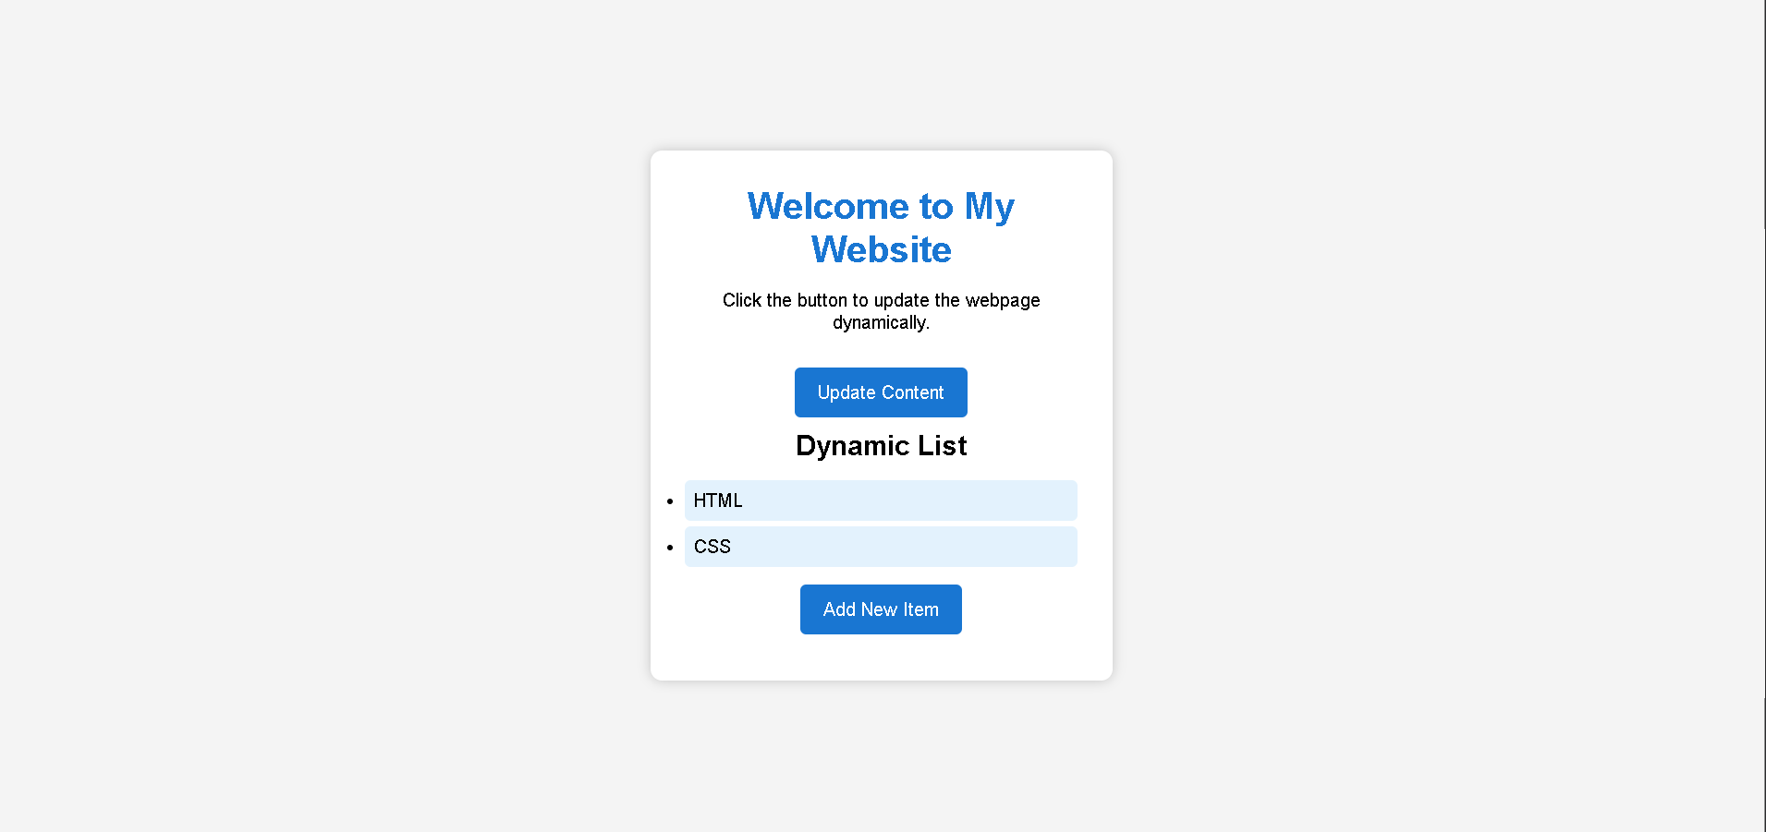

Conclusion

The Document Object Model (DOM) represents a webpage as a tree of objects that JavaScript can manipulate. DOM manipulation allows webpages to update content dynamically without reloading, making websites interactive and responsive. By using JavaScript methods such as getElementById(), querySelector(), textContent, innerHTML, and event listeners, developers can create efficient dynamic interfaces. Optimizing DOM operations and improving user experience results in faster, more responsive, and user-friendly web applications.

Code of Conduct:

I S.SHIVA RANGA REDDY (192411178) (Name / Reg No) certify that this submission is my original work and that I have adhered to the guidelines specified for this assessment. I understand that any violation of academic integrity rules will result in disciplinary action.

Signature of the student: B. Sai Manoj Kumar

RUBRICS FOR CALCULATION:

Criteria | Weightage | Level 4 – Exemplary (5 Marks) | Level 3 – Proficient (4 Marks) | Level 2 – Developing (2–3 Marks) | Level 1 – Beginning (0–1 Mark)
Conceptual Understanding | 30 | Demonstrates clear and complete understanding of the concept | Good understanding with minor gaps | Basic understanding with some misconceptions | Poor or incorrect understanding
Accuracy of Answer | 25 | Completely correct answer with no errors | Mostly correct with minor errors | Partially correct with noticeable errors | Incorrect or irrelevant answer
Application of Knowledge | 20 | Correctly applies concepts to solve the question/problem | Applies concepts with minor mistakes | Limited or partially correct application | No or incorrect application
Completeness of Response | 15 | Covers all required parts of the question | Covers most parts with minor omissions | Covers only some parts | Incomplete or missing response
Clarity & Presentation | 10 | Clear, concise, and well-organized answer | Understandable with minor issues | Somewhat unclear or poorly structured | Difficult to understand

